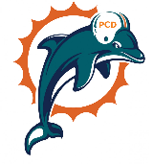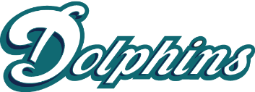

Plant City

**Corporate Sponsorship Fundraising Contest**

Welcome dolphin family! We are so excited to kick off our 2023 season! Athletes, this year you won’t just be competing out on the field or cheer mat! You will be competing against each other to get as many sponsorships as you can! We need all fins on deck!

**How it works**

Take your fundraising packet, go out into the community and raise those funds! You can find digital versions of the sponsorship levels on the PCD website.

**Important details**

The contest will run July 22nd-August 10th 2023. All sponsorships need to be turned in to Nikki Martinez in the board room by August 10th. If you have any questions, please reach out to pcdcorporatefundraising@gmail.com

Please keep track of your sponsorships on your contest form. As it will be turned in together with any funds you raise. Donations can be made via cash, check (made out to Plant City Dolphins), Venmo (@PC-Dolphins), and Cash App ($PCDolphins). Please make sure to add your business name and athlete name if doing a digital payment.

**Prizes**

* **1st Place Winner**-will receive a voucher for 50% off one cheer or football registration for the Fall 2024 season, one pair of Air pods, a Plant City Dolphin swag bag and a voucher for one free meal per home game from the PCD concession stand for the Fall 2023 season.
* **2nd & 3rd Place Winners**- will receive a voucher for 25% off one cheer or football registration for the Fall 2023 season, a Plant City Dolphin swag bag and a voucher for one free meal per home game from the PCD concession stand for the Fall 2023 season.
* **The 1st Place Winner from each team on cheer and football**- will receive a voucher for one free meal from PCD concessions per home game for the Fall 2023 season (if the 1st place winner has already placed in the overall top three, prize will go to 2nd place).

