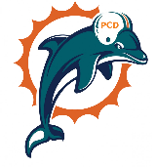
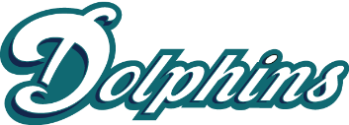
Plant City Dolphins Youth Football & Cheer
Plant City
Corporate Sponsorship Levels

$1500 Diamond Sponsorship
- Five social media shout outs during the fall season
- Logo on https://www.plantcitydolphins.com/ with link to website
- Name announced during home games
- Sign mounted on Plant City Dolphins concession stand
- Opportunity to “pop up” at one approved Plant City Dolphin home game to market your business

$1000 Platinum Sponsorship
- Three social media shout outs during the fall season
- Logo on https://www.plantcitydolphins.com/ with link to website
- Name announced during home games
- Sign mounted on Plant City Dolphins concession stand

$600 Gold Sponsorship
- Two social media shout outs during the fall season
- Logo on https://www.plantcitydolphins.com/ with link to website
- Name announced during home games

$400 Silver Sponsorship
- One social media shout out during the fall season
- Logo on https://www.plantcitydolphins.com/ with link to website

$100 Bronze Sponsorship
- One social media shout out during the fall season

